***Sports Club***

** To have a healthy life, it is better to join a sports club **

***Table of Contents:***

1. **Story Behind the Idea**

* The challenges faced by sports clubs.
* Motivation for developing the system.

1. **Information Offered to the Users**

* Details on what users can access and manage, including players, tournaments, and financials.

1. **Data Stored by the System**

* Overview of data types such as player information, financial records, and match details.

1. **Where is the Data Coming From?**

* Sources of data input, including players, coaches, and financial departments.

1. **The Target User**

* Identification of primary users such as managers, coaches, players, and financial officers.

1. **Similar Systems**

* Analysis of existing systems with similar features.
* Comparison to highlight unique aspects of your system.

1. **Benefit to the Users**

* Advantages of using the system for different stakeholders.
* Improved efficiency, communication, and management.

1. **Diagrams and Visual/Logical Design**

* System architecture.
* User interface designs.
* Data flow diagrams.

1. **Team Recognition**

* Introduction to the team behind the system.
* Roles and contributions of each member.

1. **Implementation Plan**

* Timeline and steps for development and deployment.

1. **Future Enhancements**

* Potential features and improvements for the system.
* **Similar Systems:**

**Sports have a great history when we consider it from management perspective. The special features of sports , its demarcation from business, and its effective management are considered as explicitly or implicitly by most authors when they write anything about social, cultural development. Sports unique nature and context have been highlighted especially. Sports is additionally complicated by the fact that it exists in both commercial and not – for – profit forms like other cultural services such as theatre, art, music, healthcare and education. Some special features of sports make it more unique by culturally and special by commercially.**

* **UNIQUE ASPECTS :**



**There are several aspects to make sports unique than everything like its multifaceted skills and a strategic approach if you are run any football team , any club or any type of sports entity, effectiveness is essential for growth and sustainable success. There are numerous skills that required such as**

* **Leadership: firstly, leader should inspire and motivate club members , build up a clear vision, and work towards ambitious goals. Secondly, as a leader you should not only gives orders but also listens the opinion of others. Other members will be inspired from you and put same efforts.**



* **Sports Club Management App:**

**Sports Club Management App are essential tool in modern strategic planning. Through the apps streamline event scheduling, offers automatic reminders, and allow for effective tracking. Use technology to make things much more easier and keep your strategy at your fingertips. It should involve short and long term club goals .**

* **BENEFITS TO THE USERS:**
* **Advantages of using different stakeholders:**

**A stakeholder in sport is an individual organization whose attitudes and actions influence the success of a sports team , participants or whole club. Participants are the fundamentals stakeholders in sports. Stakeholder can increase the transparency between organization and public . It plays vital role in success and failure . There are numerous stakeholders may include such as players, participants , staff, volunteers, commercial partners, members son on. Here main stakeholder may be consider to players because if player joins and give good feedback as well give their best in his games so it may be make club much more successful and famous.**

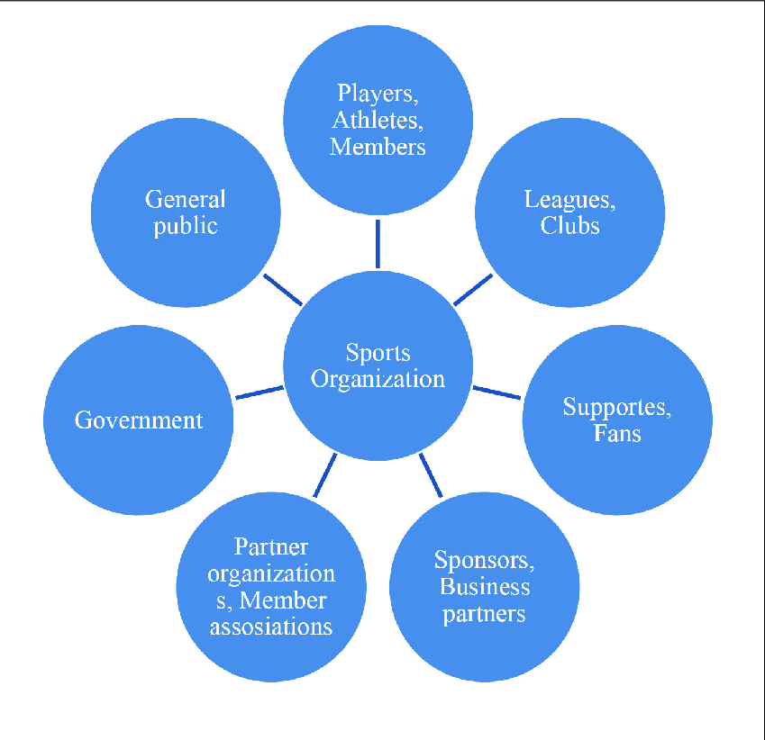[**https://www.researchgate.net/publication/332473390/figure/fig1/AS:748891146289152@1555560971653/Key-stakeholders-of-the-sports-organization-Alm-2013.png**](https://www.researchgate.net/publication/332473390/figure/fig1/AS:748891146289152@1555560971653/Key-stakeholders-of-the-sports-organization-Alm-2013.png)

* **IMPROVED EFFICIENCY , COMMUNICATION AND MANAGEMENT:**

**First of all the club volunteers is one of the most underappreciated roles in most social spheres . But good staff , members make the club more successful and famous . Volunteers should get some recognition and awards for their efforts so they may give their best to do something big. VOLUNTEERS OF THE YEAR award should be introduced so others may be inspired too .**

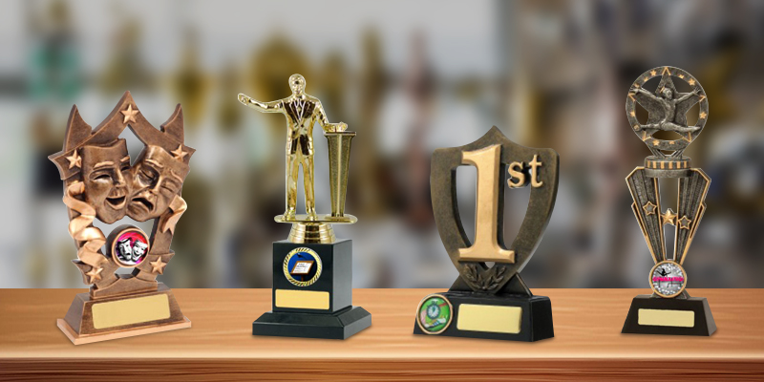

* **DO SOMETHING DIFFERENT to make your club more interested and provide facilities to staff members and players also . Ensure that full security is providing also so nobody can worry about it especially parents they feel satisfy , asking members to give feedback so they may know about their drawbacks and their good things also, gather information about better decision making and conducting seminars so on ......**
* **COMMUNICATION:**

**This plays a significant role in every field , bussiness even daily to daily life but here we talk about communication in sports club here it is the glue that holds a sports club together. Establish clear and open communication channels between club leaders and other members. It’s not about conveying your message or sharing information it's all about the listening the opinions and values and build an environment in which everyone can easily share their ideas and concerns. Social media , online communication platforms, websites, links are some ways to keep members in touch and keep communication alive .**



* **EFFECTIVE FINANCIAL MANAGEMENT:**

**It is a critical environment for the management of sports club , it is essential to establish a clear an d realistic budget, manage income and other expenses responsibility and seek for additional funding when need . The club need a bank account , a cashbook is a journal in which all the clunb’s receipts and payments are recorded. There will be receipts but cashbooks records the details of all transactions .The club will require an annual budget. Thids is the main responsibility of the treasurer and is agreed on by the club’s management committee. Adjust and modify until you have realistic and reasonable budget, add what you know about the coming year, should have proper plan till now and future (at least for next year), club should have insurance , it will depends upon the club’s assets, size and activities. Given the commitment and contribution that volunteers make , it’s important that they are protected from any potential risks. The choice of insurance company will depend on the policies , cover and costs that they are able to offer the club.**

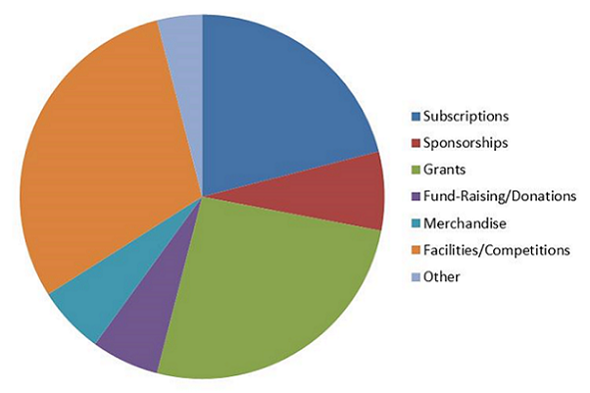

[**https://www.asa.org.nz/images/230420-ftlotg.png**](https://www.asa.org.nz/images/230420-ftlotg.png)

* **DAIGRAM AND VISUAL/LOGICAL DESIGNS:**
* **System architecture:**

**To design and build a new sports club is an impressive achievement. You want to put your best foot forward when your company sets out to design a sports facility, and others aspects are also consider . There are numerous things need to remember while designing a sports club :**

* **Zoning and site planning:**

**Firstly you need to think about the site because sports centre needs open ground as well as built areas; hence leaving it spread on the ground. It becomes inevitable to plan your site , its topography, surroundings, and climate of the city. Zoning of functions according to the need of the user and the functions.**

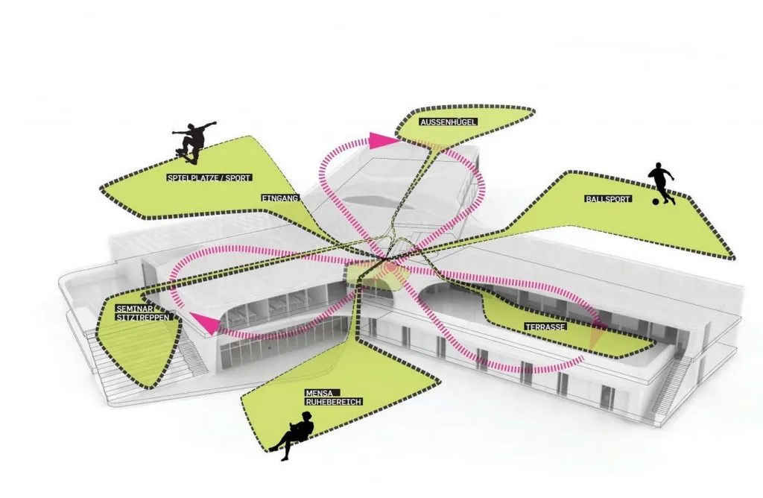

[**https://i0.wp.com/www.re-thinkingthefuture.com/wp-content/uploads/2020/08/A1632-10-things-to-remember-while-designing-sports-clubs-Image-2-1024x668.jpg**](https://i0.wp.com/www.re-thinkingthefuture.com/wp-content/uploads/2020/08/A1632-10-things-to-remember-while-designing-sports-clubs-Image-2-1024x668.jpg)

* **CONSTRUCTION MATERIAL:**

**The construction of sports facility can be highly expensive depending on the facilities, programmes provide to the users . The material collection is also the part of climate and context . The use of materials should be available locally and in abundances the part of construction system while the materials which are exported from other regions of the country can be used sparsely. For example , in Italy the sports club is designed with wood , stell , and round glass such that there is optimum natural light inside the built form.**

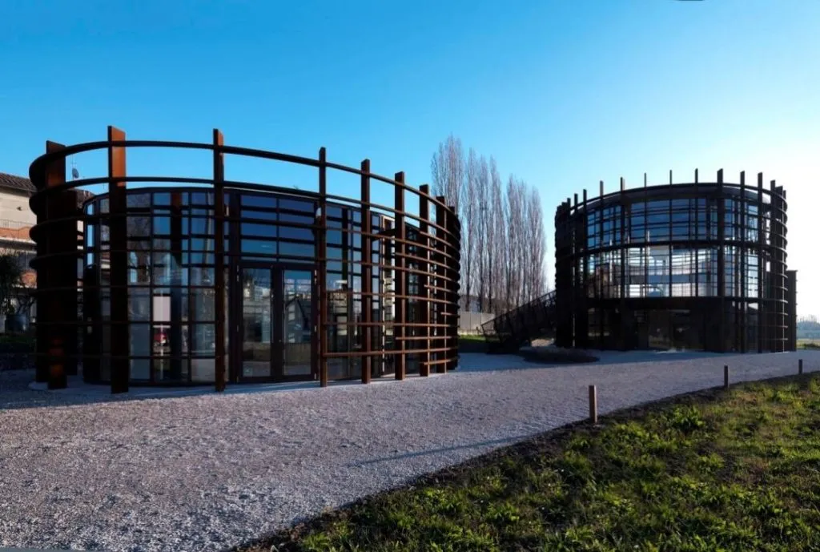

[**https://i0.wp.com/www.re-thinkingthefuture.com/wp-content/uploads/2020/08/A1632-10-things-to-remember-while-designing-sports-clubs-Image-20-1024x689.jpg**](https://i0.wp.com/www.re-thinkingthefuture.com/wp-content/uploads/2020/08/A1632-10-things-to-remember-while-designing-sports-clubs-Image-20-1024x689.jpg)

* **FUTURE EXPANSION:**

**It is crucial to take a few measurements so that there is room for future expansion in the facility and the footfall managed accordingly. If there is enough space so you will able expand the centre in future.**

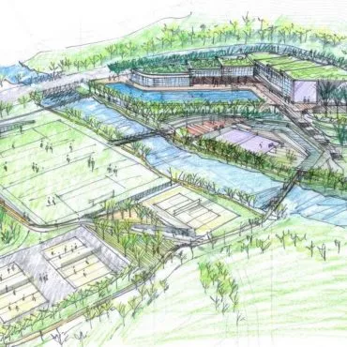

[**https://i0.wp.com/www.re-thinkingthefuture.com/wp-content/uploads/2020/08/A1632-10-things-to-remember-while-designing-sports-clubs-Image-1-370x370.jpg**](https://i0.wp.com/www.re-thinkingthefuture.com/wp-content/uploads/2020/08/A1632-10-things-to-remember-while-designing-sports-clubs-Image-1-370x370.jpg)

* **USER INTERFACE DESIGN FOR SPORTS CLUB:**
* **The selected user interface design for the sporting club’s should prioritize ease of use , and visually appealing layout.**
* **There are some consideration should include:**
* **Responsive design : Ensuring the interface is accessible and functional across various devices and screen sizes.**
* **Accessibility: Ensuring the interface compiles with accessibility standards to accommodate users with disabilities.**
* **Feedback Mechanisms: Incorporating feedback mechanisms to provide users with confirmation of actions and error notifications**
* **Content Uploads: Measuring the volume and type of content uploaded by users , such as photos, videos, or documents.**
* **Report Generation: Monitoring the generation and distribution of reports to stakeholders , such as financial reports or performance analytics.**

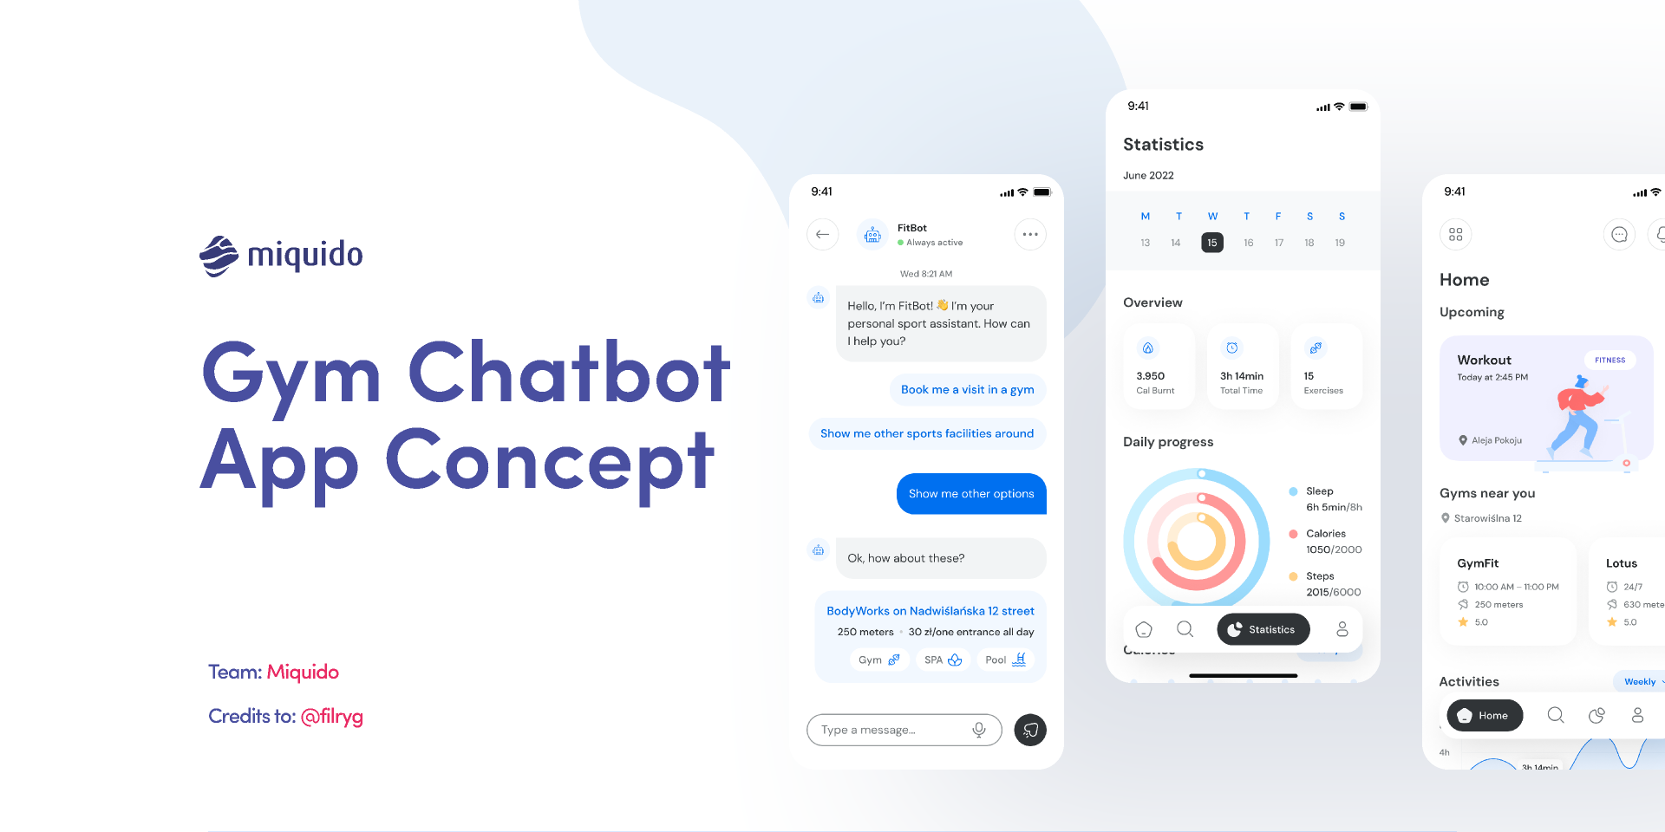

<https://s3-alpha.figma.com/hub/file/2077629787/3376fae9-4d28-4624-8b12-ae4f9926bec0-cover.png>

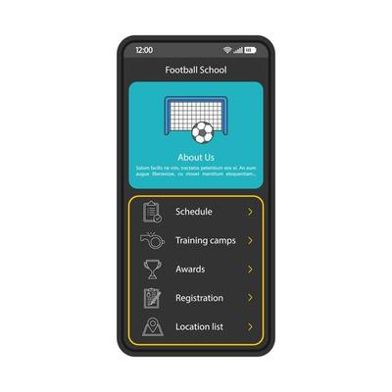

[**https://static.vecteezy.com/system/resources/thumbnails/004/184/723/small_2x/football-school-smartphone-interface-template-mobile-app-page-black-design-layout-sports-application-flat-ui-soccer-club-website-screen-schedule-training-camps-location-on-phone-display-vector.jpg**](https://static.vecteezy.com/system/resources/thumbnails/004/184/723/small_2x/football-school-smartphone-interface-template-mobile-app-page-black-design-layout-sports-application-flat-ui-soccer-club-website-screen-schedule-training-camps-location-on-phone-display-vector.jpg)

* **DATA FLOW DIAGRAM:**

